Table of Contents

Databricks and Spark Continued 1

Note About Removing Content from the FileStore 1

Getting Started 1

About Spark DataFrames 2

Spark DataFrames for Distributed Data Sources 2

Logistic Regression 3

The Machine Learning Pipeline 5

Connecting to a Database 9

Getting Started with Databases 9

Creating Tables Using the UI 10

Viewing Tables 11

Creating Database Tables in Code 12

Using Pandas Dataframes in Databricks 12

Running R in PySpark 14

# Databricks and Spark Continued

## Note About Removing Content from the FileStore

To remove files from the FileStore run this command:

|  |
| --- |
| dbutils.fs.rm("/FileStore/tables/pat_diamonds2.json") |

## Getting Started

To work through the exercises, likely a new cluster will be needed. To create one choose the plus sign in the left margin and then click **Cluster**. After, click **Create a notebook**.

 

## About Spark DataFrames

In Spark, a DataFrame is a distributed collection of data which is organized into named columns. Once built, Spark DataFrames provide a domain-specific language for distributed data manipulation. They are evaluated lazily.

## Spark DataFrames for Distributed Data Sources

Example 1: Logistic with Distributed Datasources

This example shows how the Spark DataFrame represents data that exists in multiple partitions. To create the different data sources, upload the **admissions.json** and **admissions.csv** files to the FileStore. These files can be found in the data sets folder.

To upload the files, from the Databricks node select **Browse file**. This choose **admissions.json** and **admissions.csv**.



When finished the JSON and csv files will exist in the **DBFS | tables** directory:



This code builds one Spark DataFrame to reference both data sources while each data source exists on a separate partition.

**Note:** To avoid format issues when loading the admissions.csv file, the following options are included in the *read.csv()* function:

inferSchema=True, header=True, multiLine=True, escape='"'

|  |
| --- |
| %python  from pyspark.sql.functions import spark_partition_id, asc, desc  # Show first two rows, as well as id’s and row counts for all partitions in df.  def showIdAndRowCount(df, title):  print("\n*** " + title)  display(df.head(2))  df.rdd.toDF()\  .withColumn("partitionId", spark_partition_id())\  .groupBy("partitionId")\  .count()\  .orderBy(asc("count"))\  .show()  # Load csv file into a Spark DataFrame.  admissionsDf1 = spark.read.csv("/FileStore/tables/admissions.csv", \  inferSchema=True, header=True, multiLine=True, escape='"')  showIdAndRowCount(admissionsDf1, "admissionsDf1")  # Load JSON file into a Spark DataFrame.  admissionsDf2 = spark.read.json("/FileStore/tables/admissions.json")  showIdAndRowCount(admissionsDf2, "admissionsDf2")  # Join both DataFrames into a single Spark DataFrame. Preserve column order.  unionDf = admissionsDf1.union(admissionsDf2.select(admissionsDf1.columns))  showIdAndRowCount(unionDf, "unionDf") |

Examining the *unionDf* DataFrame shows that each of its data sources exist in a separate partition (see Figure 1).

Figure 1: Viewing Partitions of the Spark Dataframe named **unionDf**

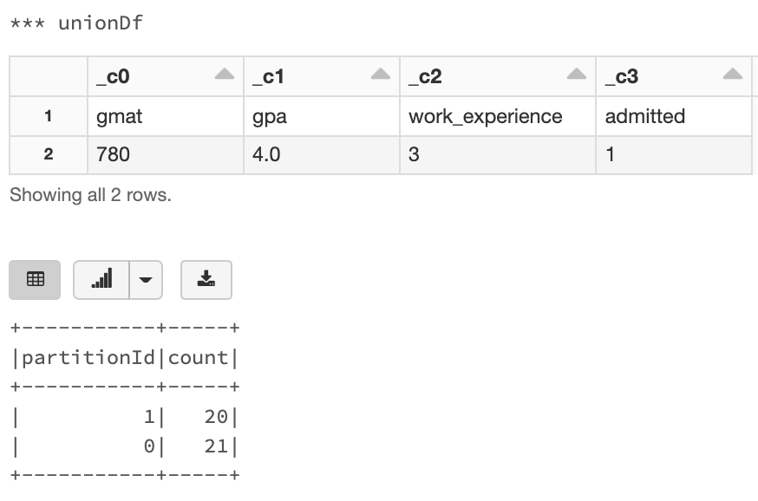

## Logistic Regression

Example 2: Logistic Regression

This example demonstrates the necessary steps to perform logistic regression with PySpark ML. The steps are:

1. An assembler is used to identify the features.
2. A classifier is initialized with the names of feature and target columns.
3. A pipeline is initialized with the assembler and classifier. (We will discuss the pipeline in more detail later.)
4. The entire transformation process for the inputs is invoked with the **fit()** function.
5. Predictions are generated by the model with the **transform()** function.

|  |
| --- |
| %python  from pyspark.ml.classification import LogisticRegression, LogisticRegressionSummary  from pyspark.ml.feature import VectorAssembler  from pyspark.ml import Pipeline  # Use assembler to define feature columns.  assembler = VectorAssembler(inputCols=['gmat', 'gpa', 'work_experience'], outputCol="features")  # Define logistic regression model with target column.  from pyspark.ml.classification import LogisticRegression  lr = LogisticRegression(featuresCol='features', labelCol='admitted', maxIter=10)  # Build pipeline with feature vector and logistic regression model.  pipeline = Pipeline(stages=[assembler, lr])  # Split the Spark DataFrame.  train, test = unionDf.randomSplit([0.75, 0.25])  # Fit the model with train and predict with test.  model = pipeline.fit(train)  predictions = model.transform(test)  print("\nShowing prediction DataFrame")  display(predictions) |

This next code cell evaluates the results of the logistic regression. The newer PySpark ML and older PySpark MlLib libraries are used to perform the transformations.

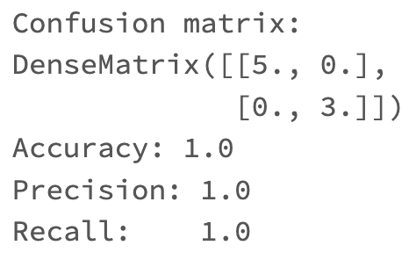

|  |
| --- |
| from pyspark.ml.evaluation import BinaryClassificationEvaluator  from pyspark.mllib.evaluation import BinaryClassificationMetrics, MulticlassMetrics  predictions = (predictions.withColumn("admitted", predictions["admitted"].cast("double")))  #evaluate the model  predictionsAndLabels = predictions.select("prediction", "admitted").rdd  metrics = MulticlassMetrics(predictionsAndLabels)  confusionMatrix = metrics.confusionMatrix()  accuracy = metrics.accuracy  precision = metrics.precision(1.0)  recall = metrics.recall(1.0)  print("Confusion matrix: ")  print(confusionMatrix)  print("Accuracy: " + str(accuracy))  print("Precision: " + str(accuracy))  print("Recall: " + str(recall)) |

## The Machine Learning Pipeline

Machine learning **pipelines** define a sequential workflow that moves data through stages. Stages are broken into transformers and estimators. **Transformers** update and modify the data. **Estimators** input the data and return a trained model.

Figure 2: Pipeline Transformers and Estimators

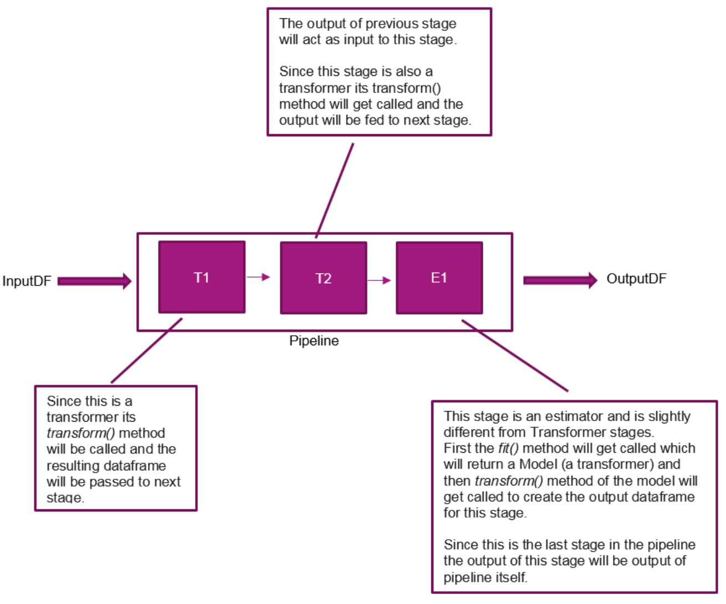

Diagram taken from: <https://medium.com/@Sushil_Kumar/machine-learning-pipelines-with-spark-ml-94cd9b4c973d>

Example 3: Logistic Regression with a PySpark Pipeline

This example shows how to use a pipeline to perform transformations on a PySpark DataFrame that is generated from a Social_Network_Ads.csv file. The DataFrame is then used to build a logistic regression model to make purchase classifications.

To start, you will need to upload the Social_Network_Ads.csv file to the FileStore area in Databricks. Then, in a Notebook, add this cell to load the data file and to split it into train and test sets.

|  |
| --- |
| %python  # Load social network data from FileStore.  socialNetworkDf = spark.read.csv("/FileStore/tables/Social_Network_Ads.csv",  header="true", inferSchema="true")  # Split the data into test and training sets.  splits = socialNetworkDf.randomSplit([0.8, 0.2], seed=1234)  train = splits[0]  test = splits[1] |

This next cell defines the stages of the pipeline. The stages are:

1. Convert Gender column of strings to column of 0’s and 1’s.
2. Set up feature vector.
3. Set up feature scaler.
4. Define classifier with feature and target column names.

Here is the code:

|  |
| --- |
| from pyspark.ml import Pipeline  from pyspark.ml.feature import StringIndexer, OneHotEncoder, VectorAssembler, StandardScaler  from pyspark.ml.classification import LogisticRegression  # 1. Create gender index column. Converts Male and Female to 0 and 1.  genderIndexer = StringIndexer().setInputCol("Gender").setOutputCol("GenderIndex")  # Define feature and target variable names.  features = ["GenderIndex", "Age", "EstimatedSalary"]  targetVariable = "Purchased"  # 2. Set up feature vector.  vectorAssembler = VectorAssembler().setInputCols(features).setOutputCol("features")  # 3. Set up feature scaler.  scaler = StandardScaler().setInputCol("features").setOutputCol("scaledFeatures")  # 4. Set classifier with features and labels.  logisticRegression = LogisticRegression().setFeaturesCol("scaledFeatures")\  .setLabelCol(targetVariable)  # Define pipeline stages.  # 1) Index gender. 2) Build feature set. 3) Scale features. 4) Prep model.  stages = [genderIndexer, vectorAssembler, scaler, logisticRegression]  pipeline = Pipeline().setStages(stages) |

The **fit()** instruction invokes the sequence of transformations within the pipeline to generate a model.

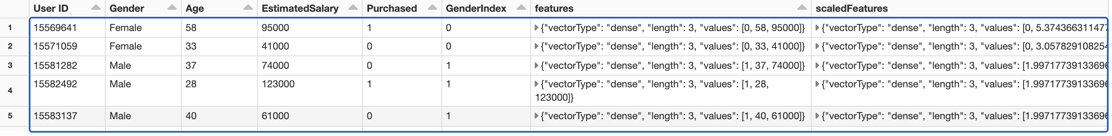

The **transform()** instruction makes the predictions.

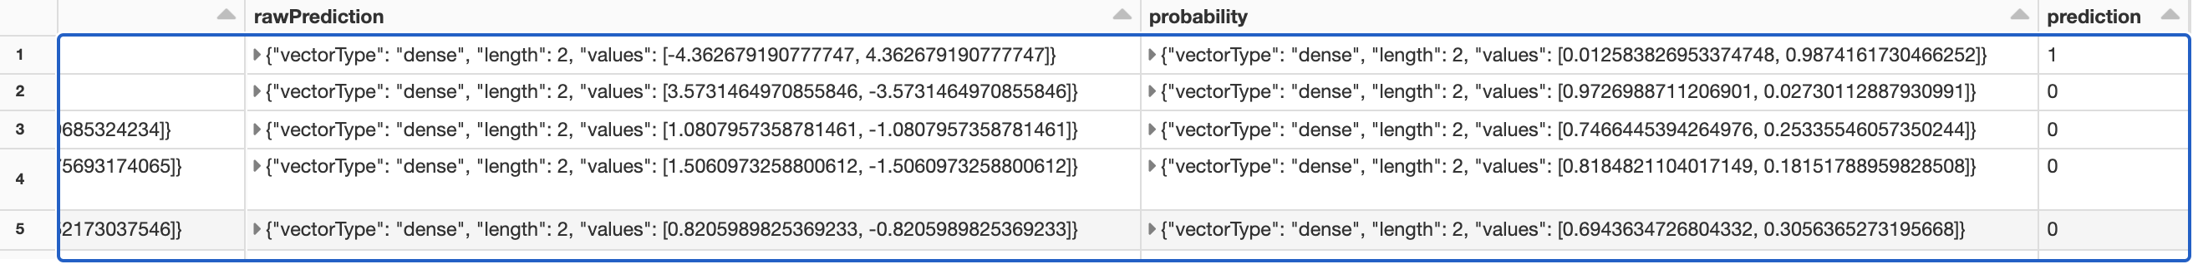

Add this code to implement the fit() and transform() functions:

|  |
| --- |
| # Get model object.  model = pipeline.fit(train)  # Generate predictions  results = model.transform(test)  display(results) |

This last code cell implements the classifier model evaluation. The results of the model are not great but the focus of this example was to examine the ML pipeline for logistic regression.

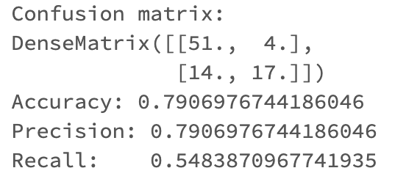

Here is the code for implementing the classifier evaluation.

|  |
| --- |
| from pyspark.ml.evaluation import BinaryClassificationEvaluator  from pyspark.mllib.evaluation import BinaryClassificationMetrics, MulticlassMetrics  # Convert 'Purchased' column to double.  predictions = (results.withColumn("Purchased", results["Purchased"].cast("double")))  # Compare predicted and actual value with MulticlassMetrics class.  predictionsAndLabels = predictions.select("prediction", "Purchased").rdd  metrics = MulticlassMetrics(predictionsAndLabels)  # Obtain statistical measures.  confusionMatrix = metrics.confusionMatrix()  accuracy = metrics.accuracy  precision = metrics.precision(1.0)  recall = metrics.recall(1.0)  print("Confusion matrix: ")  print(confusionMatrix)  print("Accuracy: " + str(accuracy))  print("Precision: " + str(accuracy))  print("Recall: " + str(recall)) |

Exercise 1 (15 marks)

Upload the iris.csv file from the COMP4949 | Datasets area to the FileStore in Databricks. Build a logistic regression model for the flower type using scaled featurres.

In English, list the steps taken to build the ML pipeline:

|  |
| --- |
| 1. Create the flower type indexer 0 for iris-setosa, 1 for iris-versicolor, 2 for iris-virginica 2. Define features and target variable names 3. Set up feature vector. 4. Set up feature scaler 5. Set classifier with features and labels. 6. Define pipeline stage 7. Get model object 8. Generate prediction 9. Compare predicted and actual value with multiclassMetrics class 10. Obtain statistical measures |

Show the instruction that defines the sequential list of stages for the pipeline:

|  |
| --- |
| 1. Index flower type. 2. Build feature set 3. Scale features 4. Prep model |

Which instruction invoked the transformations on the Spark DataFrame?

|  |
| --- |
| # Compare predicted and actual value with MulticlassMetrics class.  predictionsAndLabels = predictions.select("prediction", "flowerTypeIndexer").rdd |

Show a screenshot of the probability and prediction columns of the results matrix after making the predictions with the model.

|  |
| --- |
|  |

Show a screenshot of the confusion matrix, accuracy, precision and recall scores after evaluating the model in Databricks.

|  |
| --- |
|  |

## Connecting to a Database

A goal of databricks is to enable easy management of data sources across multiple nodes. Part of the data source mix includes databases. Databricks Community Edition has a built-in database. This next section will introduce some basics for working with the database.

Databricks provides MySQL and PostgreSQL as one of the many infrastructure services.

Example 4: Creating a Table and Implementing Basic SQL Scripts

For more information see: <https://docs.databricks.com/data/tables.html#types-of-tables>

### Getting Started with Databases

To use the default database that is packaged with Databricks, you need to have a live cluster.

### Creating Tables Using the UI

There are several ways to create database tables including through code. To keep things simple I will use the UI.

Click  **Data** in the sidebar. The Databases and Tables folders display.



1. In the Databases folder, select a database. This is only possible though if you are connected to a live node so please see the previous section to ensure your cluster is active.
2. Then, above the Tables folder, click Create Table.



1. Choose a data source and follow the steps in the corresponding section to configure the table.

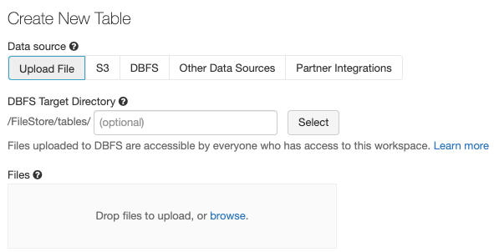

For now, choose the **truck.csv** file. However, you could choose a json file, specify s3 buckets or other data sources. Then click Preview Table, name your table and click **Create Table** when ready.

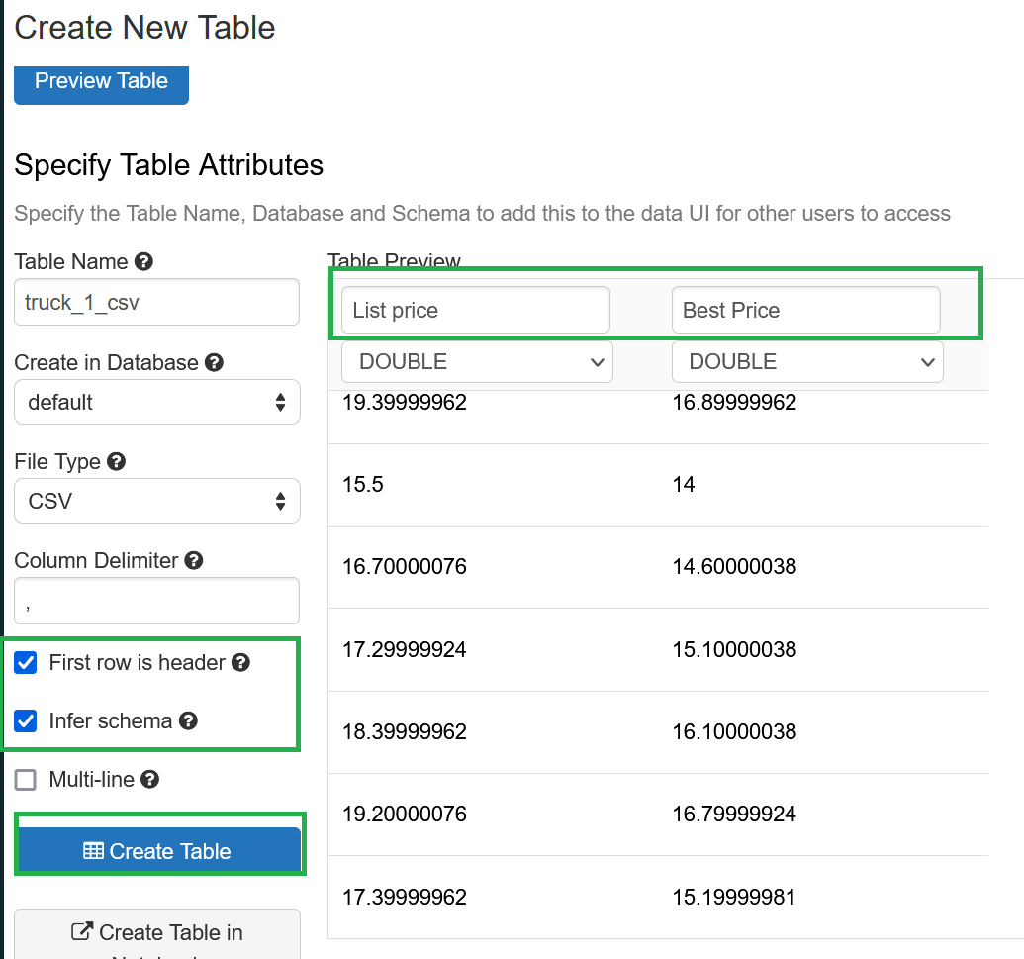

### Viewing Tables

To view tables. Click  **Data** in the sidebar. Databricks selects a running cluster to which you have access. The Databases folder displays the list of databases with the default database selected. The Tables drop area displays the list of tables in the default database.





Now it is possible to query the table.

|  |
| --- |
| %sql  SELECT * FROM my_truck_table |

### Creating Database Tables in Code

Example 5: Creating Data Tables in Code

You can also create database tables in code within a Databricks notebook.

|  |
| --- |
| %sql  --DROP TABLE Book;  CREATE TABLE Book (  book int,  title VARCHAR(35)  );  INSERT INTO Book VALUES(1,'Harry Potter');  SELECT * FROM Book; |

Exercise (2 marks)

Create a table with your first name in the name of the table. Then show a screenshot of the table listing from the data tab. The listing should appear similar to the following but with your name in it.



Show your screenshot here.

|  |
| --- |
|  |

## Using Pandas Dataframes in Databricks

Example 6: Working with Pandas DataFrames

Just like with regular notebooks that you are used to working with, you can still load your data and work with the libraries that we have covered already. This example shows how to perform linear regression with a Pandas dataframe.

This line of code reads the data from the file store (as long as you uploaded the csv file). The data is read into a PySpark dataframe:

wineSparkDf = spark.read.csv("/FileStore/tables/winequality.csv",

header="true", inferSchema="true")

This line of code converts the PySpark dataframe into a Pandas dataframe:

pandasDf = wineSparkDf.toPandas()

Here is the full example.

|  |
| --- |
| %python  # CELL A  # Load wine quality dataset into Spark dataframe.  wineSparkDf = spark.read.csv("/FileStore/tables/winequality.csv",  header="true", inferSchema="true")  print("Original dataframe length: " + str(wineSparkDf.count()))  # Get packages for performing LinearRegression without the ML pipeline  import pandas as pd  from sklearn.model_selection import train_test_split  from sklearn.linear_model import LinearRegression  from sklearn import metrics  import statsmodels.api as sm  import numpy as np  # Show all columns.  pd.set_option('display.max_columns', None)  # Increase number of columns that display on one line.  pd.set_option('display.width', 1000)  # Convert PySpark dataframe to Pandas df  pandasDf = wineSparkDf.toPandas()  print(pandasDf.head(3))  X = pandasDf[['volatile acidity', 'chlorides', 'sulphates', 'alcohol']]  # Adding an intercept *** This is requried ***. Don't forget this step.  # The intercept centers the error residuals around zero  # which helps to avoid over-fitting.  X = sm.add_constant(X)  y = pandasDf['quality']  X_train, X_test, y_train, y_test = train_test_split(X, y, test_size=0.2)  model = sm.OLS(y_train, X_train).fit()  predictions = model.predict(X_test) # make the predictions by the model  print(model.summary())  print('Root Mean Squared Error:', np.sqrt(metrics.mean_squared_error(y_test, predictions))) |

## Running R in PySpark

It is possible to run R in PySpark if you prefer to implement your data models with R.

Example : Coding with R in Databricks

To code in R, choose R as the default language when creating a new notebook. To create a new notebook, click on the Databricks icon and select Create a Blank Notebook.



Then, give the Notebook a name, choose R as the default language and then click Create.

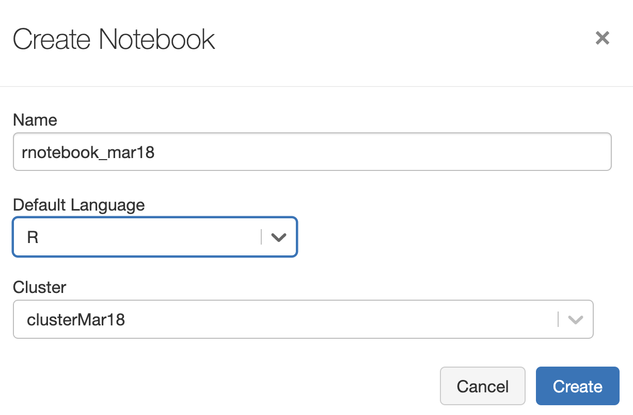

Add this code to print a string and to append and display a series of strings.

|  |
| --- |
| # Print string.  print("Hello World!")  # Append words  print(paste("How","are","you?"), quote = FALSE) |

Here is the output that is displayed when running the cell.



Exercise (2 marks)

Using R, print out your first and last name with the print() and paste() instructions. Show your code here:

|  |
| --- |
| # Print string.  print("Hyerim Jess Shin")  # Append words  print(paste("Hyerim","Jess","Shin"), quote = FALSE) |

Show your output here:

|  |
| --- |
|  |

Example : Reading Data Into a PySpark DataFrame with R

This example demonstrates how to load data into a PySpark data frame. Starting with Example 7, upload the truck.csv file from the data sets folder.

Next, to read the data into a PySpark dataframe with R add this code to a new cell in the same Notebook that you used in Example 7.

|  |
| --- |
| %r  require("SparkR")  sparkDF <- read.df(source = "csv", path = "/FileStore/tables/truck.csv",  header = "true", inferSchema = "true")  display(sparkDF) |

When running the code above, the following output will appear:

